FAMILY FUN DOG SHOW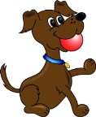
£1 /entry / class

1. Cutest Puppy 6—12 months old
2. Prettiest Bitch
3. Most Handsome Dog
4. The Scruffiest Dog
5. The Waggiest Tail
6. Best Child Handler
7. Best party trick
8. Best 6 legs (dog & owner)
9. Best Brace (matching or opposite)
10. Most Obedient
First place prize winners to compete in Best in Show
DOG SHOW COMMENCES AT 2.00PM

